**LAPORAN TUBES**

**PEMROGAMAN BASIS DATA**

**(GABUNGAN JOBSHEET VBNET AWAL – AKHIR)**



Disusun Oleh :

Ade Rahmat Setiawan (3.34.21.0.01)

Ahmad Irvan Maulana (3.34.21.0.03)

**PROGRAM STUDI TEKNIK INFORMATIKA**

**JURUSAN TEKNIK ELEKTRO**

**POLITEKNIK NEGERI SEMARANG**

**2022/2023**

# **PEMROGAMAN DATABASE 10 (Microsoft Visual Basic.Net)**

**Langkah Kerja Praktikum**

1. **Form Menu Utama**

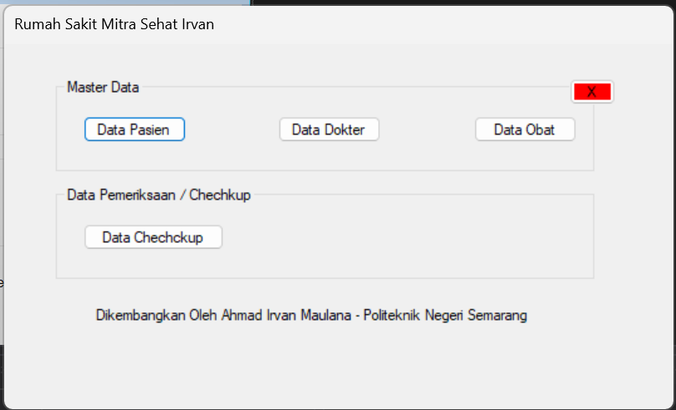

1. **Form Data Pasien**

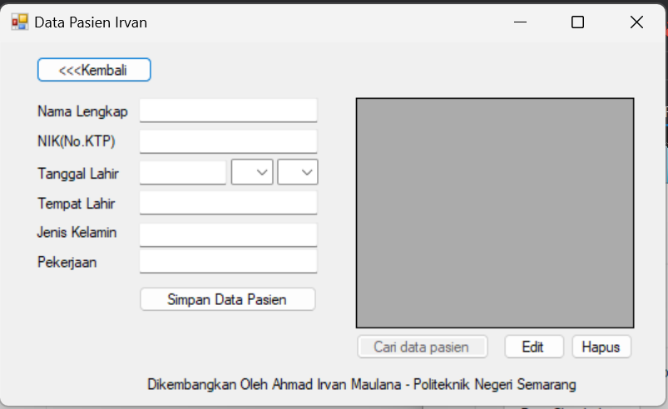

1. **Form Entry Data Dokter**

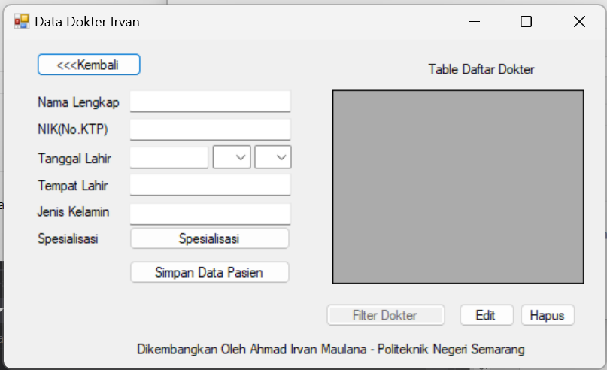

1. **Form Entry Data Obat**

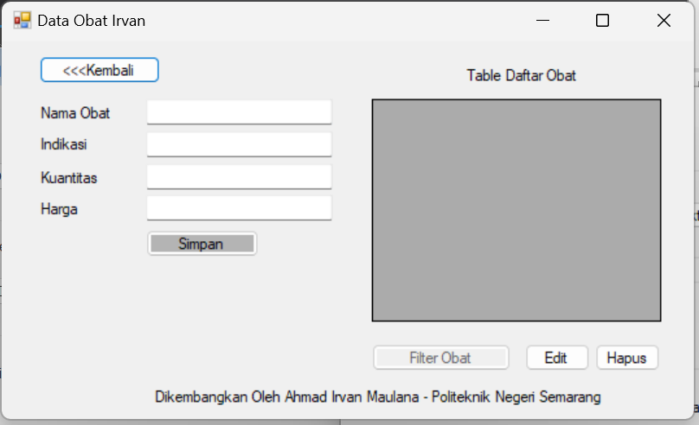

1. **Kode Program**

**Form 1**

Public Class Form1

Private Sub Form1_Load(sender As Object, e As EventArgs) Handles MyBase.Load

End Sub

Private Sub Button1_Click(sender As Object, e As EventArgs) Handles Button1.Click

Dim Form2 As New Form2

Form2.Show()

End Sub

Private Sub Button2_Click(sender As Object, e As EventArgs) Handles Button2.Click

Dim Form3 As New Form3

Form3.Show()

End Sub

Private Sub Button3_Click(sender As Object, e As EventArgs) Handles Button3.Click

Dim Form4 As New Form4

Form4.Show()

End Sub

End Class

**Form 2**

Public Class Form2

Private Sub Button1_Click(sender As Object, e As EventArgs) Handles Button1.Click

Close()

End Sub

Private Sub ComboBox2_SelectedIndexChanged(sender As Object, e As EventArgs) Handles ComboBox2.SelectedIndexChanged

End Sub

Private Sub ComboBox1_SelectedIndexChanged(sender As Object, e As EventArgs) Handles ComboBox1.SelectedIndexChanged

End Sub

Private Sub DataGridView1_CellContentClick(sender As Object, e As DataGridViewCellEventArgs) Handles DataGridView1.CellContentClick

End Sub

Private Sub TextBox6_TextChanged(sender As Object, e As EventArgs) Handles TextBox6.TextChanged

End Sub

Private Sub TextBox5_TextChanged(sender As Object, e As EventArgs) Handles TextBox5.TextChanged

End Sub

Private Sub TextBox4_TextChanged(sender As Object, e As EventArgs) Handles TextBox4.TextChanged

End Sub

Private Sub TextBox3_TextChanged(sender As Object, e As EventArgs) Handles TextBox3.TextChanged

End Sub

Private Sub TextBox2_TextChanged(sender As Object, e As EventArgs) Handles TextBox2.TextChanged

End Sub

Private Sub Label7_Click(sender As Object, e As EventArgs) Handles Label7.Click

End Sub

Private Sub Label6_Click(sender As Object, e As EventArgs) Handles Label6.Click

End Sub

Private Sub Label5_Click(sender As Object, e As EventArgs) Handles Label5.Click

End Sub

Private Sub Label4_Click(sender As Object, e As EventArgs) Handles Label4.Click

End Sub

Private Sub Label3_Click(sender As Object, e As EventArgs) Handles Label3.Click

End Sub

Private Sub Label2_Click(sender As Object, e As EventArgs) Handles Label2.Click

End Sub

Private Sub Label1_Click(sender As Object, e As EventArgs) Handles Label1.Click

End Sub

Private Sub Button4_Click(sender As Object, e As EventArgs) Handles Button4.Click

End Sub

Private Sub Button3_Click(sender As Object, e As EventArgs) Handles Button3.Click

End Sub

Private Sub Button2_Click(sender As Object, e As EventArgs) Handles Button2.Click

End Sub

Private Sub Button5_Click(sender As Object, e As EventArgs) Handles Button5.Click

End Sub

Private Sub Form2_Load(sender As Object, e As EventArgs) Handles MyBase.Load

End Sub

End Class

**Form 3**

Public Class Form3

Private Sub Label7_Click(sender As Object, e As EventArgs) Handles Label7.Click

End Sub

Private Sub Button1_Click(sender As Object, e As EventArgs) Handles Button1.Click

Close()

End Sub

End Class

**Form 4**

Public Class Form4

Private Sub Button1_Click(sender As Object, e As EventArgs) Handles Button1.Click

Close()

End Sub

Private Sub Form4_Load(sender As Object, e As EventArgs) Handles MyBase.Load

End Sub

End Class

**Saat Kode Dijalankan**

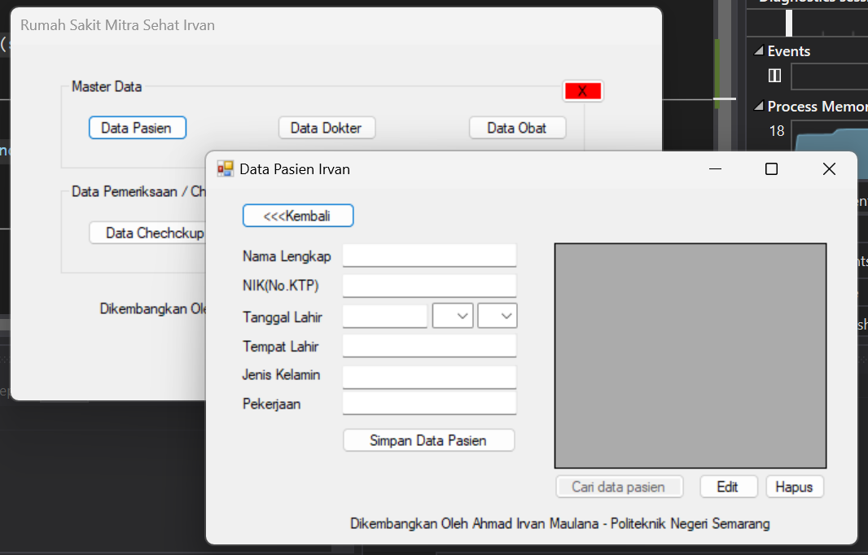

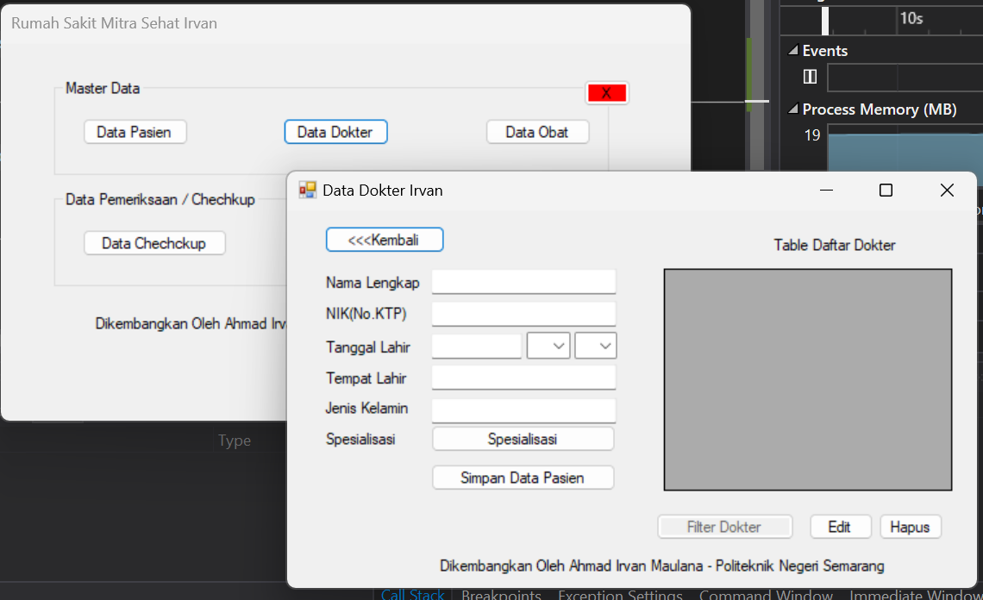

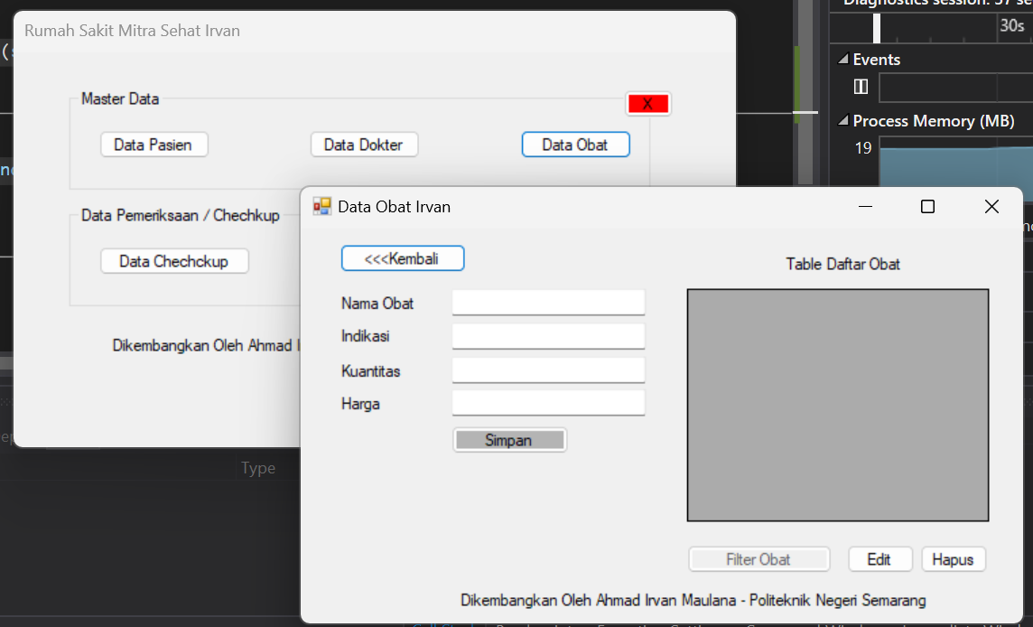

# **PEMROGAMAN DATABASE 11 (Menghubungkan Dengan Mysql)**

**Langkah Praktikum**

1. **Membuat Database**

**Kode :**

ALTER TABLE `doctors` ADD `nik` VARCHAR(16) NOT NULL AFTER `fullname`, ADD `birth_date` DATE NOT NULL AFTER `nik`, ADD `birth_place` VARCHAR(50) NOT NULL AFTER `birth_date`, ADD `sex` ENUM('M','F') NOT NULL AFTER `birth_place`; UPDATE `doctors` SET `sex` = 'F', `birth_date` = '1993-06-15', `birth_place` = 'Boston' WHERE `doctors`.`id` = 1; UPDATE `doctors` SET `birth_date` = '1988-05-11' WHERE `doctors`.`id` = 2; UPDATE `doctors` SET `birth_date` = '1990-01-09' WHERE `doctors`.`id` = 3; UPDATE `doctors` SET `birth_date` = '1991-09-23' WHERE `doctors`.`id` = 4; UPDATE `doctors` SET `birth_date` = '1995-08-17' WHERE `doctors`.`id` = 5; UPDATE `doctors` SET `birth_date` = '1990-09-01' WHERE `doctors`.`id` = 6;

Hasil :

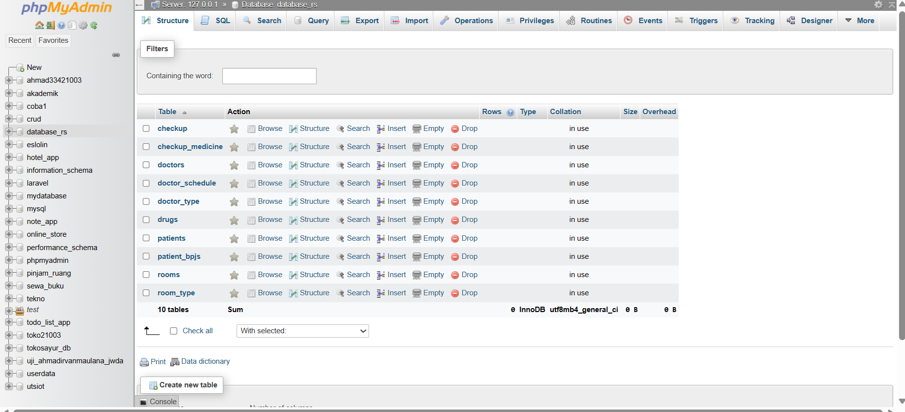

1. **Membuat View data doktor**

**Kode :**

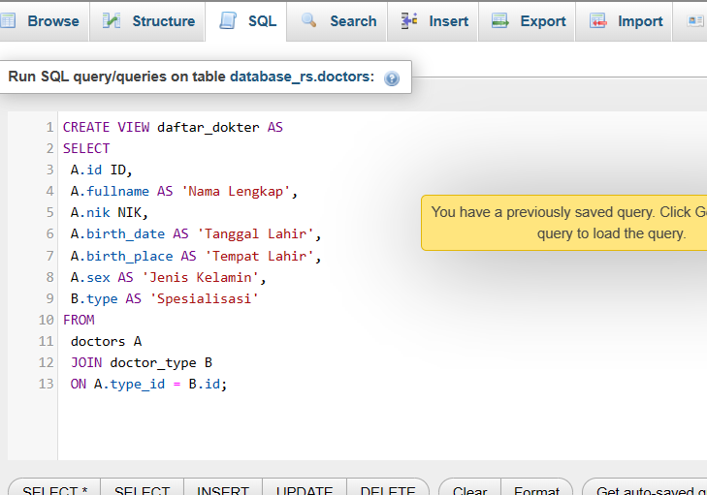

**Hasil :**

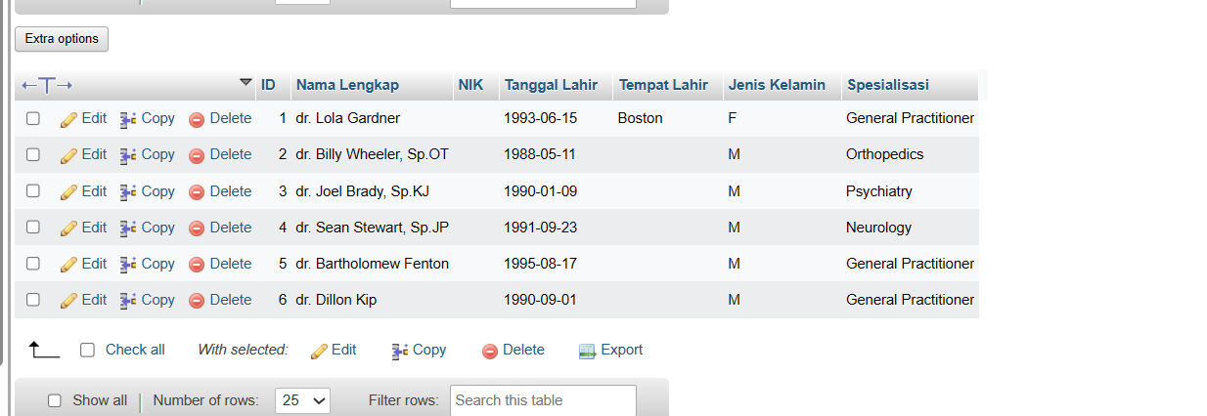

1. **Install Package Mysql**

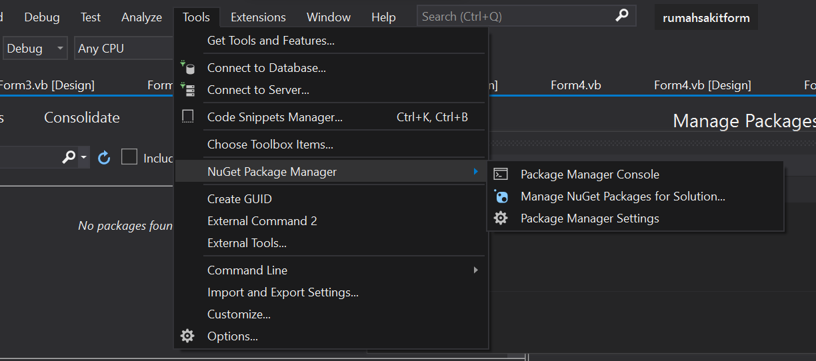

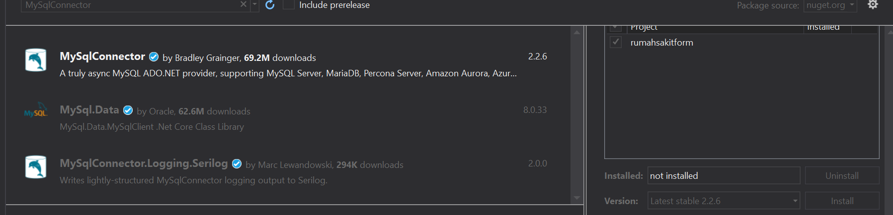

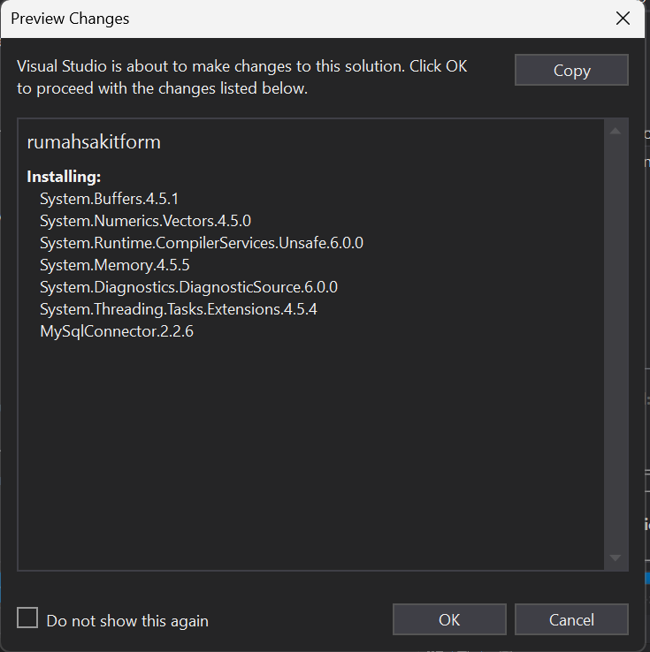

1. **Menampilkan Pilihan Spealisasi**

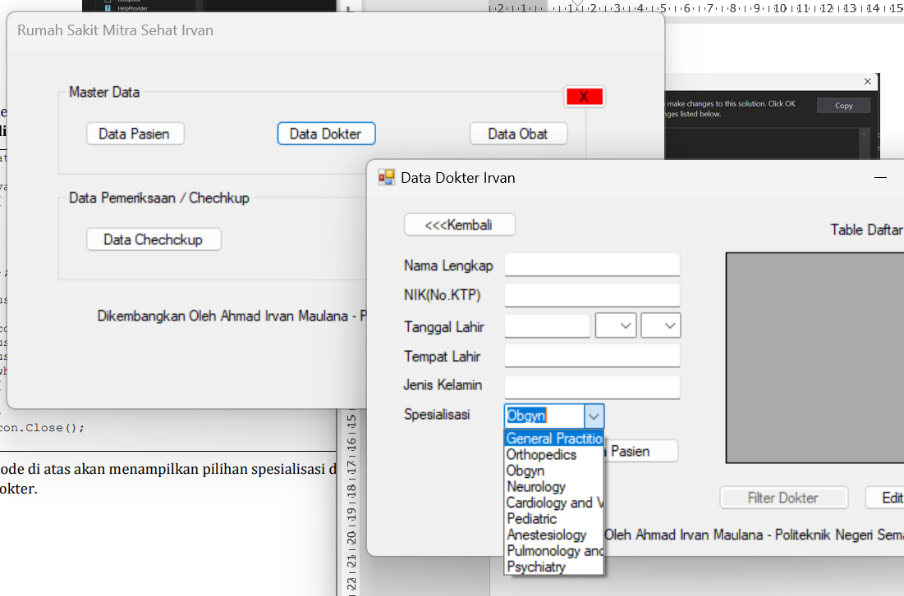

1. **Menambahkan Data Pada Grid View**

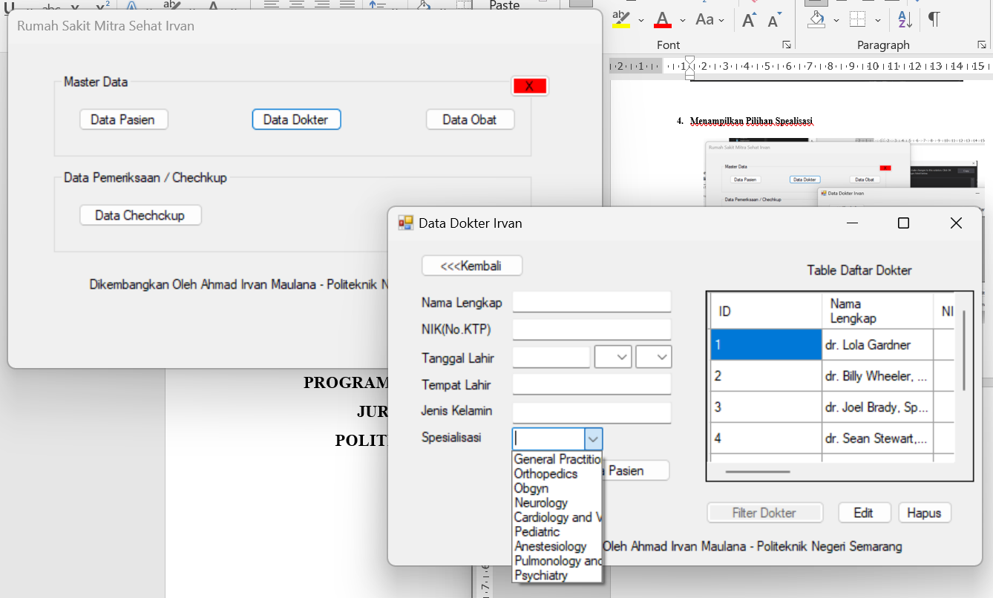

**TUGAS**

1. **MEMBUAT VIEW DATA PASIEN DAN DATA OBAT**

* **Data pasien**

**Kode**

CREATE VIEW daftar_pasien AS

SELECT

P.id,

P.fullname AS 'Nama Lengkap',

P.birth_date AS 'Tanggal Lahir',

P.birth_place AS 'Tempat Lahir',

P.sex AS 'Jenis Kelamin',

P.occupation AS 'Pekerjaan',

P.entry_date AS 'Tanggal Masuk',

BP.patient_id,

BP.bpjs_no,

BP.registered_date

FROM

patients P

LEFT JOIN

patient_bpjs BP ON P.id = BP.patient_id;

**Hasil**

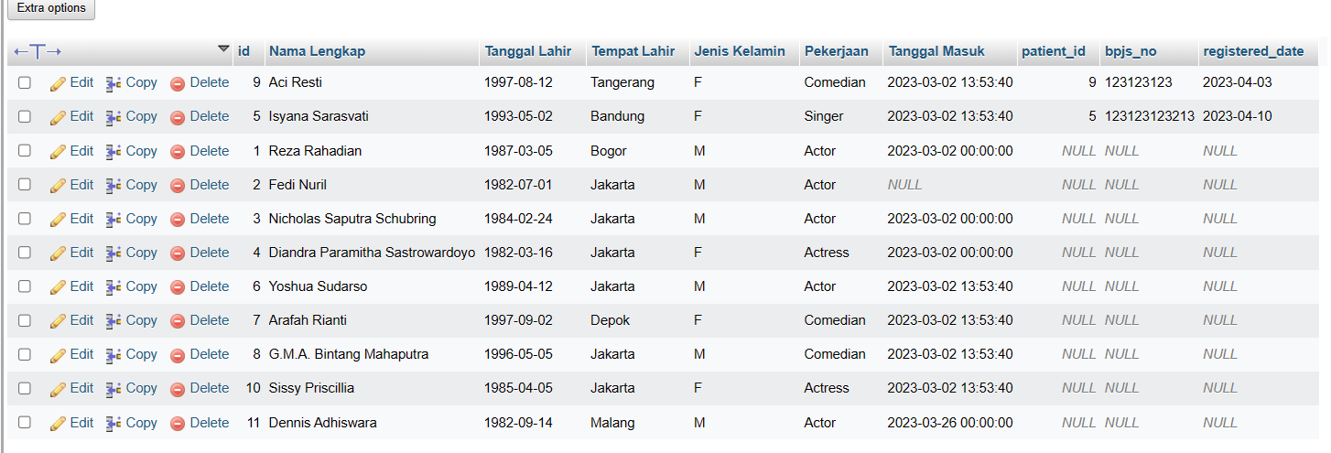

* **Data Obat**

**Kode**

CREATE VIEW data_obat AS

SELECT

D.id,

D.name AS 'Nama Obat',

D.diagnose AS 'Diagnosa',

D.quantity AS 'Kuantitas',

D.price AS 'Harga'

FROM

drugs D;

**Hasil**

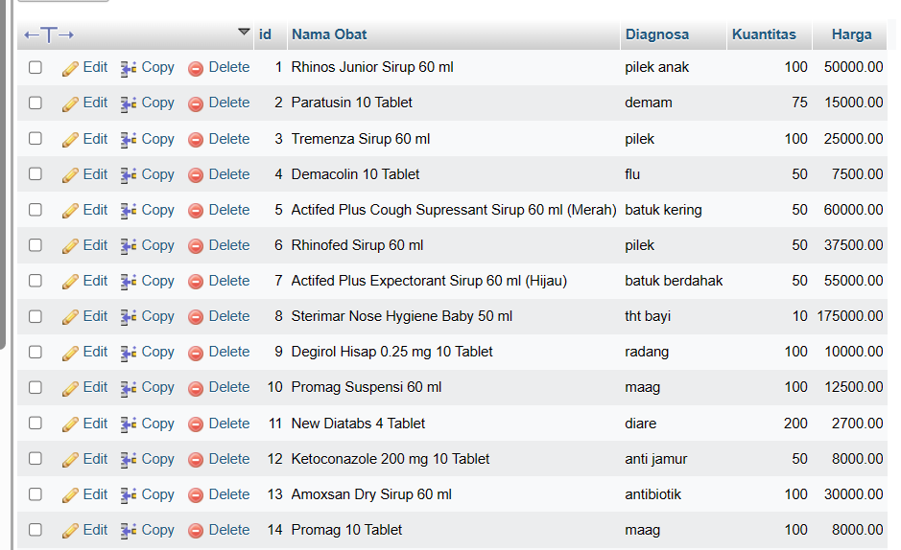

1. **TAMPILKAN DATA PASIEN DAN DATA OBAT PADA GRID VIEW**

Data Pasien

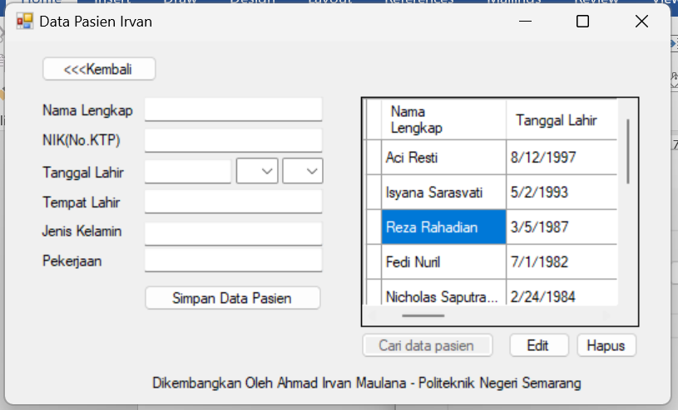

Data obat

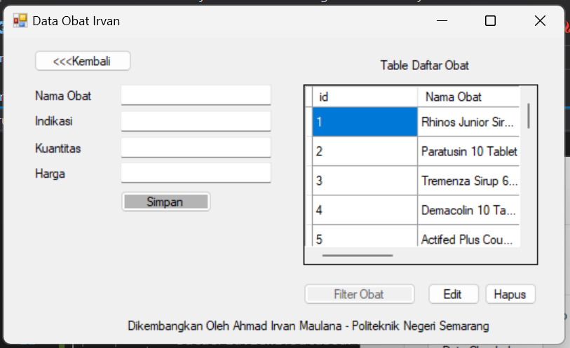

# **PEMROGAMAN DATABASE 12 (Operasi Crud)**

1. **Langkah Kerja Praktikum**
2. **Menyesuaikan UI Form**

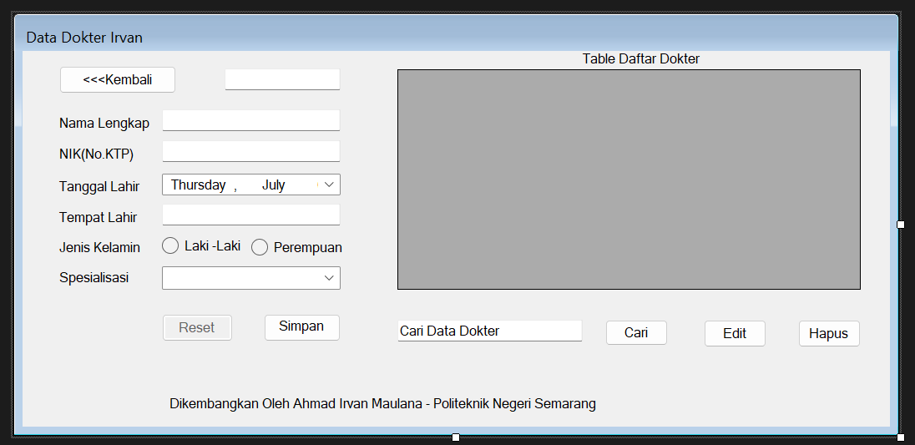

1. **Menyesuaikan Property Form**

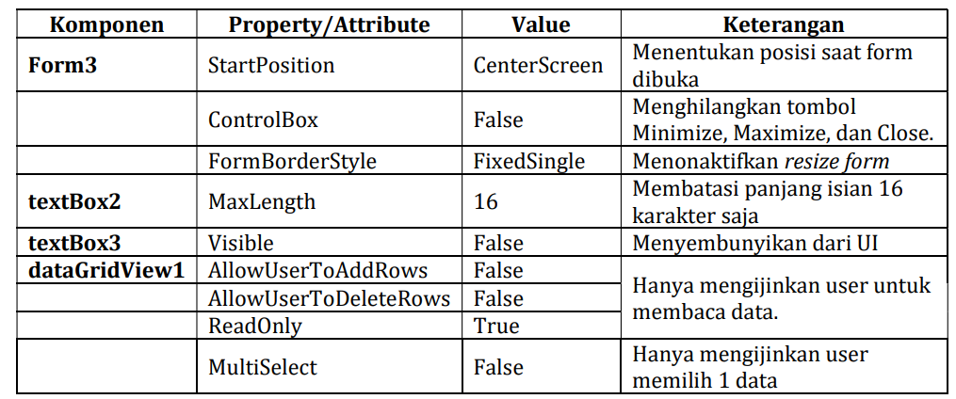

1. **Membuat Fungsi Pencarian**

Kode :

Private Sub search_data_dokter(ByVal keyword As String)

con.Open()

Dim dataCommand As New MySqlCommand("SELECT * FROM daftar_dokter WHERE `Nama Lengkap` LIKE @keyword", con)

dataCommand.Parameters.AddWithValue("@keyword", "%" & keyword & "%")

Dim dataReader As MySqlDataReader = dataCommand.ExecuteReader()

Dim dataTable As New DataTable()

dataTable.Load(dataReader)

DataGridView1.DataSource = dataTable

con.Close()

End Sub

**pada button 6**

**kode :**

Private Sub button6_Click(ByVal sender As Object, ByVal e As EventArgs) Handles Button6.Click

Me.search_data_dokter(TextBox5.Text)

End Sub

1. **Membuat Fungsi Create**

Untuk melakukan loading data

Kode :

Private Sub load_data_dokter()

Me.con.Open()

Dim dataCommand As New MySqlCommand("SELECT * FROM daftar_dokter", Me.con)

Dim dataReader As MySqlDataReader = dataCommand.ExecuteReader()

Dim dataTable As New DataTable()

dataTable.Load(dataReader)

DataGridView1.DataSource = dataTable

Me.con.Close()

End Sub

**Untuk melakukan Reset**

**Kode :**

Private Sub clear_form()

TextBox1.Text = ""

TextBox2.Text = ""

TextBox3.Text = ""

TextBox4.Text = ""

DateTimePicker2.ResetText()

RadioButton1.Checked = True

RadioButton2.Checked = False

ComboBox1.SelectedItem = Nothing

End Sub

**Kode Pada button 2**

Private Sub button2_Click(ByVal sender As Object, ByVal e As EventArgs) Handles Button2.Click

Dim nama_lengkap = TextBox1.Text

Dim nik = TextBox2.Text

Dim tgl_lahir = DateTimePicker2.Value.ToString("yyyy-MM-dd")

Dim tmp_lahir = TextBox4.Text

Dim gender = ""

Dim isChecked As Boolean = RadioButton1.Checked

If isChecked Then

gender = "M"

Else

gender = "F"

End If

Dim spesialisasi As String = ComboBox1.Text

Dim spesialisasi_components As String() = spesialisasi.Split(" "c)

Me.con.Open()

Dim dataCommand As MySqlCommand

If TextBox3.Text = "" Then

dataCommand = New MySqlCommand("INSERT INTO doctors (fullname, nik, birth_date, birth_place, sex, type_id) VALUES (@fullname, @nik, @birth_date, @birth_place, @sex, @type_id)", Me.con)

Else

dataCommand = New MySqlCommand("UPDATE doctors SET fullname = @fullname, nik = @nik, birth_date = @birth_date, birth_place = @birth_place, sex = @sex, type_id = @type_id WHERE id = @doctor_id", Me.con)

dataCommand.Parameters.AddWithValue("@doctor_id", TextBox3.Text)

End If

dataCommand.Parameters.AddWithValue("@fullname", nama_lengkap)

dataCommand.Parameters.AddWithValue("@nik", nik)

dataCommand.Parameters.AddWithValue("@birth_date", tgl_lahir)

dataCommand.Parameters.AddWithValue("@birth_place", tmp_lahir)

dataCommand.Parameters.AddWithValue("@sex", gender)

dataCommand.Parameters.AddWithValue("@type_id", spesialisasi_components(0))

Dim affected_rows As Integer = dataCommand.ExecuteNonQuery()

If affected_rows > 0 Then

MessageBox.Show("Berhasil menyimpan data", "Informasi")

End If

Me.con.Close()

Me.clear_form()

Me.load_data_dokter()

End Sub

1. **Membuat Fungsi Update**

Kode :

Private Sub load_single_dokter(ByVal doctor_id As Integer)

con.Open()

Dim dataCommand As New MySqlCommand("SELECT * FROM doctors WHERE id = @doctor_id", con)

dataCommand.Parameters.AddWithValue("@doctor_id", doctor_id)

Dim dataReader As MySqlDataReader = dataCommand.ExecuteReader()

If dataReader.HasRows = True Then

dataReader.Read()

TextBox1.Text = dataReader.GetString(dataReader.GetOrdinal("fullname"))

TextBox2.Text = dataReader.GetString(dataReader.GetOrdinal("nik"))

Dim birthDate As DateTime = dataReader.GetDateTime(dataReader.GetOrdinal("birth_date"))

DateTimePicker2.Value = birthDate

TextBox4.Text = dataReader.GetString(dataReader.GetOrdinal("birth_place"))

If dataReader.GetString(dataReader.GetOrdinal("sex")) = "M" Then

RadioButton1.Checked = True

RadioButton2.Checked = False

Else

RadioButton1.Checked = False

RadioButton2.Checked = True

End If

Dim type_id As String = dataReader.GetInt16(dataReader.GetOrdinal("type_id")).ToString()

Dim spesialisasi As String = String.Format("{0}.", type_id)

Dim comboIndex As Integer = ComboBox1.FindString(spesialisasi)

ComboBox1.SelectedIndex = comboIndex

Else

MessageBox.Show("Data Tidak Ditemukan", "Perhatian")

End If

con.Close()

End Sub

**Kode pada button3 :**

Private Sub Button3_Click(sender As Object, e As EventArgs) Handles Button3.Click

Dim rowIndex As Integer = DataGridView1.CurrentCell.RowIndex

Dim doctor_id As String = DataGridView1.Rows(rowIndex).Cells(0).Value.ToString()

TextBox3.Text = doctor_id

Me.load_single_dokter(Integer.Parse(doctor_id))

End Sub

**Pengubahan kode pada button 2:**Private Sub button2_Click(ByVal sender As Object, ByVal e As EventArgs) Handles Button2.Click

Dim nama_lengkap = TextBox1.Text

Dim nik = TextBox2.Text

Dim tgl_lahir = DateTimePicker2.Value.ToString("yyyy-MM-dd")

Dim tmp_lahir = TextBox4.Text

Dim gender = ""

Dim isChecked As Boolean = RadioButton1.Checked

If isChecked Then

gender = "M"

Else

gender = "F"

End If

Dim spesialisasi As String = ComboBox1.Text

Dim spesialisasi_components As String() = spesialisasi.Split(" "c)

Me.con.Open()

Dim dataCommand As MySqlCommand

If TextBox3.Text = "" Then

dataCommand = New MySqlCommand("INSERT INTO doctors (fullname, nik, birth_date, birth_place, sex, type_id) VALUES (@fullname, @nik, @birth_date, @birth_place, @sex, @type_id)", Me.con)

Else

dataCommand = New MySqlCommand("UPDATE doctors SET fullname = @fullname, nik = @nik, birth_date = @birth_date, birth_place = @birth_place, sex = @sex, type_id = @type_id WHERE id = @doctor_id", Me.con)

dataCommand.Parameters.AddWithValue("@doctor_id", TextBox3.Text)

End If

dataCommand.Parameters.AddWithValue("@fullname", nama_lengkap)

dataCommand.Parameters.AddWithValue("@nik", nik)

dataCommand.Parameters.AddWithValue("@birth_date", tgl_lahir)

dataCommand.Parameters.AddWithValue("@birth_place", tmp_lahir)

dataCommand.Parameters.AddWithValue("@sex", gender)

dataCommand.Parameters.AddWithValue("@type_id", spesialisasi_components(0))

Dim affected_rows As Integer = dataCommand.ExecuteNonQuery()

If affected_rows > 0 Then

MessageBox.Show("Berhasil menyimpan data", "Informasi")

End If

Me.con.Close()

Me.clear_form()

Me.load_data_dokter()

End Sub

**Membuat Fungsi Delete**

**Kode :**

Private Sub drop_single_dokter(doctor_id As Integer)

Me.con.Open()

Dim dataCommand As New MySqlCommand("DELETE FROM doctors WHERE id = @doctor_id", Me.con)

Try

dataCommand.Parameters.AddWithValue("@doctor_id", doctor_id)

dataCommand.ExecuteNonQuery()

MessageBox.Show("Berhasil menghapus data", "Berhasil")

Catch ex As Exception

MessageBox.Show("Gagal menghapus data. Dokter pernah melakukan pemeriksaan (checkup).", "Perhatian")

End Try

Me.con.Close()

End Sub

**Pada button 4**

**Kode :**

Private Sub button4_Click(sender As Object, e As EventArgs) Handles Button4.Click

Dim answer = MessageBox.Show("Anda yakin ingin menghapus data ini?", "Perhatian", MessageBoxButtons.YesNo)

If answer = DialogResult.Yes Then

Dim rowIndex = DataGridView1.CurrentCell.RowIndex

Dim doctor_id = DataGridView1.Rows(rowIndex).Cells(0).Value.ToString()

Me.drop_single_dokter(Short.Parse(doctor_id))

Me.load_data_dokter()

End If

End Sub

1. **Tugas**
2. **Jelaskan Fungsi Dari MessageBox**

**Jawab :**

Form Pesan (Messagebox)

Form yang bertugas untuk menampilkan pesan keterangan terhadap suatu kejadian yang diterima oleh aplikasi.

1. **Buat fungsi CRUD untuk data pasien, sesuai dengan contoh pada data dokter.**

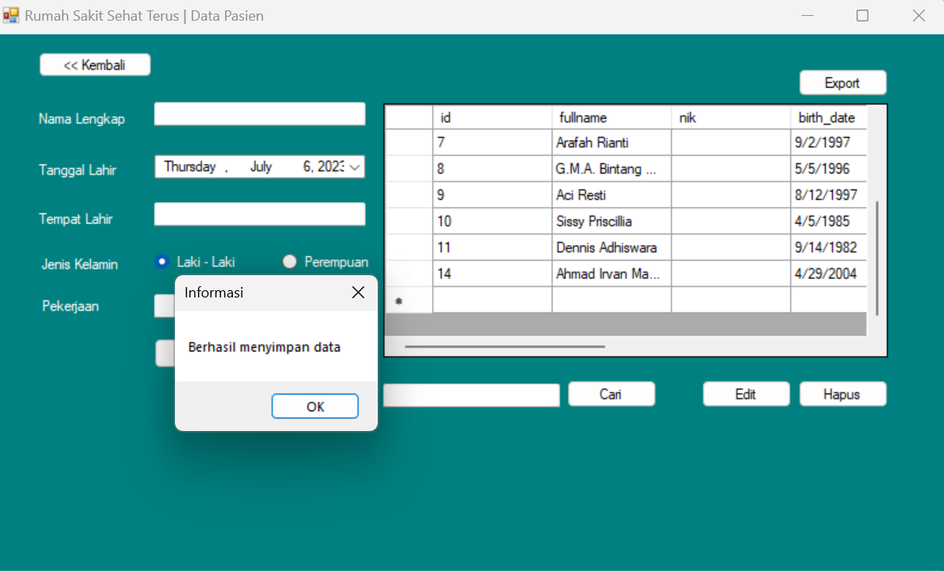

1. **Buat fungsi CRUD untuk data obat, sesuai dengan contoh pada data dokter**

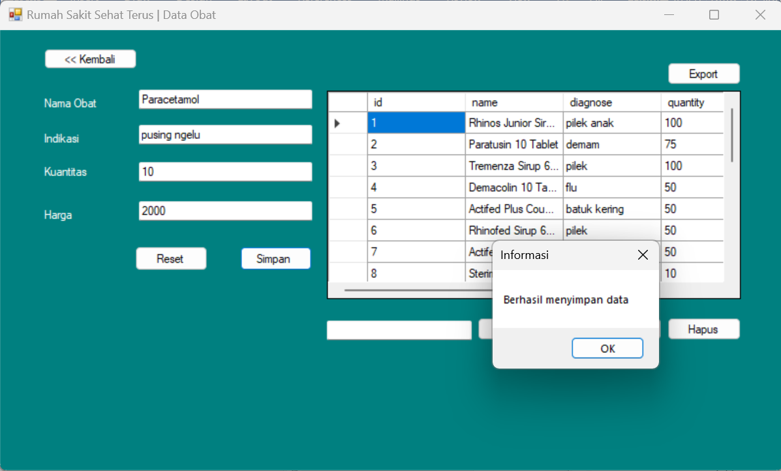

# **PEMROGAMAN DATABASE 13 (Export Ke Microsoft Exel)**

1. **Langkah Kerja Praktikum**
2. **Install Package ClosedXML**

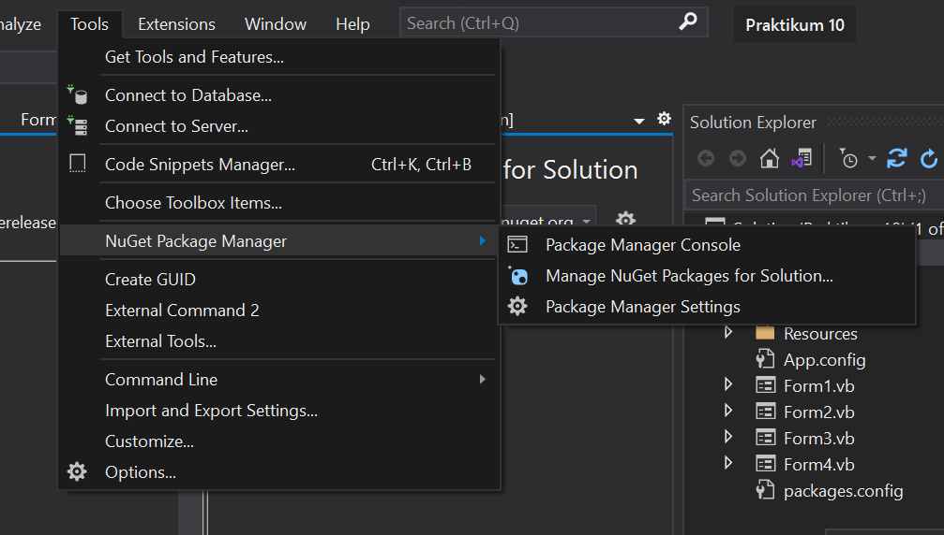

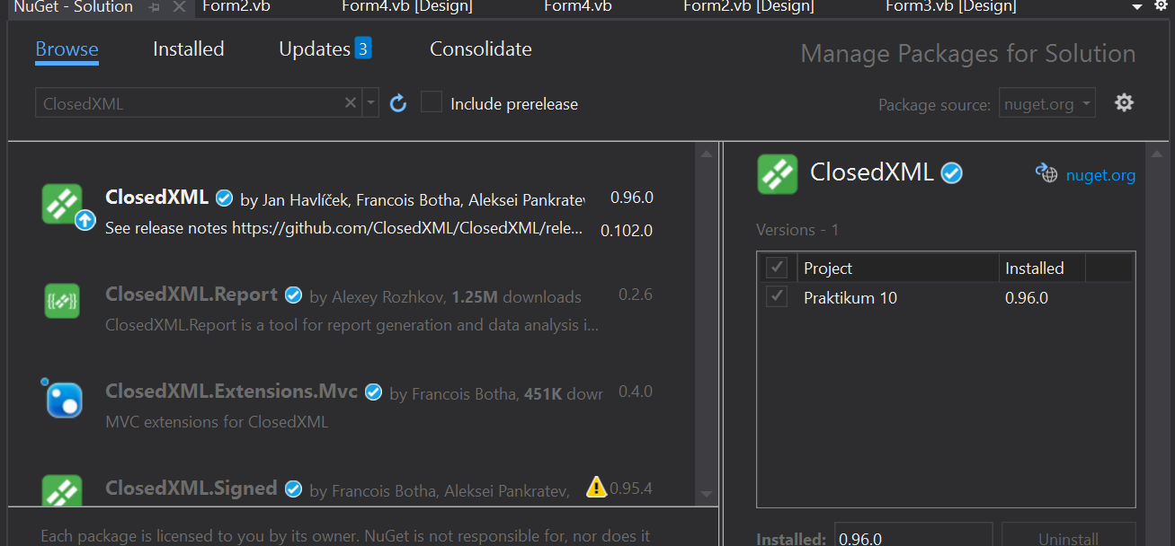

1. **Menyelesaikan UI Form**

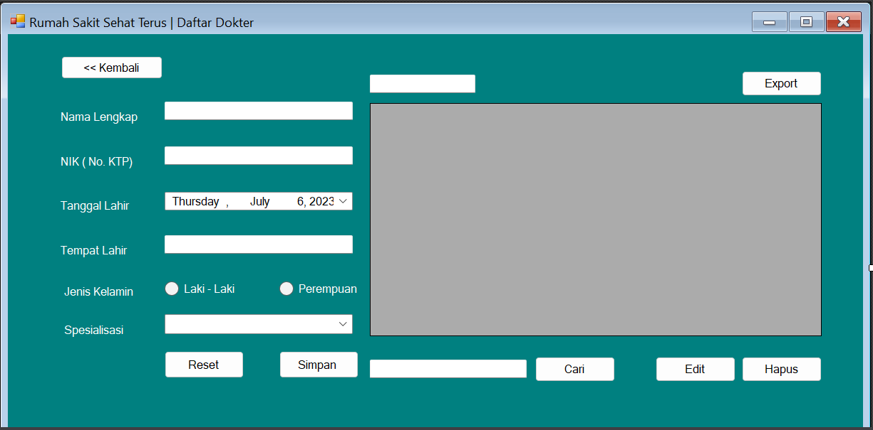

1. **Menambahkan Kode**

**Kode pada button 7:**

Private Sub Button7_Click(sender As Object, e As EventArgs) Handles Button7.Click

' membuat komponen datatable

' dimulai dari baris di bawah, komponen pada dataGridView1 dipindahkan ke komponen baru yaitu DataTable pada variabel dt

Dim dt As New DataTable()

' menambahkan kolom datagridview1 ke datatable

For Each col As DataGridViewColumn In DataGridView1.Columns

dt.Columns.Add(col.Name)

Next

' menambahkan baris/record data dari datagridview1 ke datatable

For Each row As DataGridViewRow In DataGridView1.Rows

Dim dRow As DataRow = dt.NewRow()

For Each cell As DataGridViewCell In row.Cells

dRow(cell.ColumnIndex) = cell.Value

Next

dt.Rows.Add(dRow)

Next

' membuat sebuah file excel di memory

Using wb As New XLWorkbook()

' menambahkan worksheet ke file excel

wb.Worksheets.Add(dt, "Sheet1")

Using stream As New MemoryStream()

wb.SaveAs(stream)

' membuka save file dialog untuk menentukan tempat penyimpanan file

Dim saveFileDialog As New SaveFileDialog()

saveFileDialog.Filter = "Excel Files|*.xlsx"

saveFileDialog.FileName = "Rekap Data Dokter.xlsx"

' melakukan cek apakah user menekan tombol simpan

If saveFileDialog.ShowDialog() = DialogResult.OK Then

' menyimpan file dengan nama dan lokasi yang dipilih oleh user

File.WriteAllBytes(saveFileDialog.FileName, stream.ToArray())

MessageBox.Show("File saved successfully.", "Success", MessageBoxButtons.OK, MessageBoxIcon.Information)

End If

End Using

End Using

End Sub

1. **Tugas**
2. **Buat fungsi Export untuk data pasien, sesuai dengan contoh pada data dokter.**

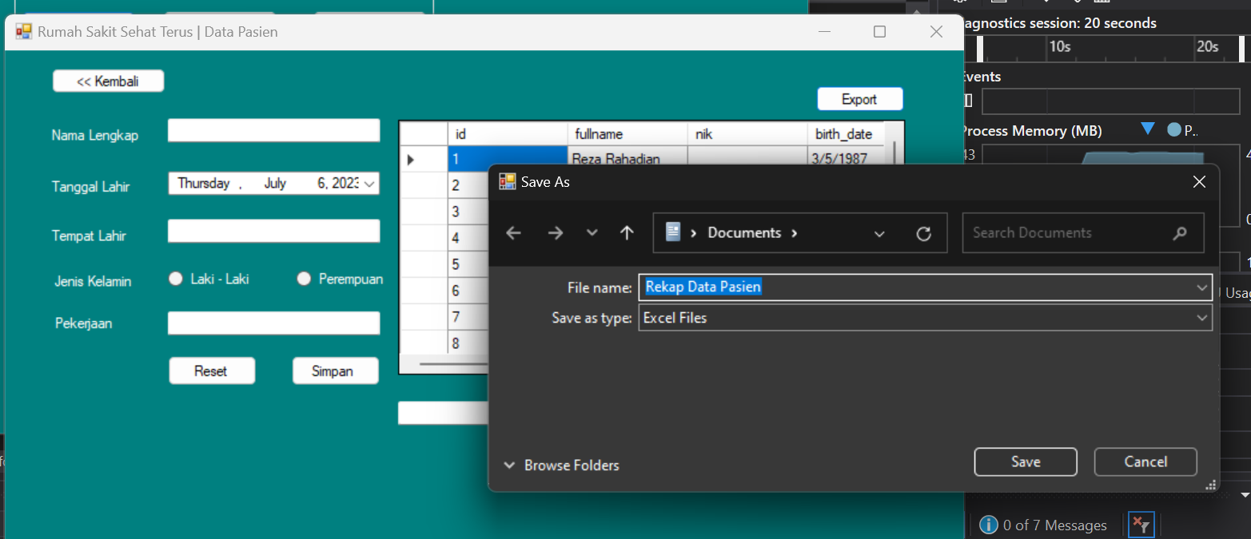

1. **Buat fungsi Export untuk data obat, sesuai dengan contoh pada data dokter  
     
   